q
COURSE CODE/TITLE: | CPE 010/Data Structures and Algorithms |  | SECTION: | CPE21S1
DATE PERFORMED: | July 23 2026 |  | DATE SUBMITTED: | July 23 2026 part 1,  July 27 2026 part 2
NAME: | Mendoza, Roy Gabriel |  | INSTRUCTOR: | Engr. JIMLORD QUEJADO

ACTIVITY NO. __3_ | LINKED LISTS
1. PROCEDURE OUTPUT
What procedures did you perform?

Table 3-1. Output of Initial/Simple Implementation
Screenshot | 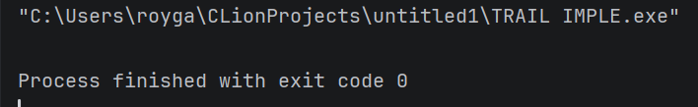
Discussion | The program was able to create a linked list but not have any of the cout or to print out the output. Since this is a node by node, we could create a looping code that will print out the contents of the nodes to show the output per.

Table 3-2. Code for the List Operations
OPERATION: | SCREENSHOT:
Traversal | 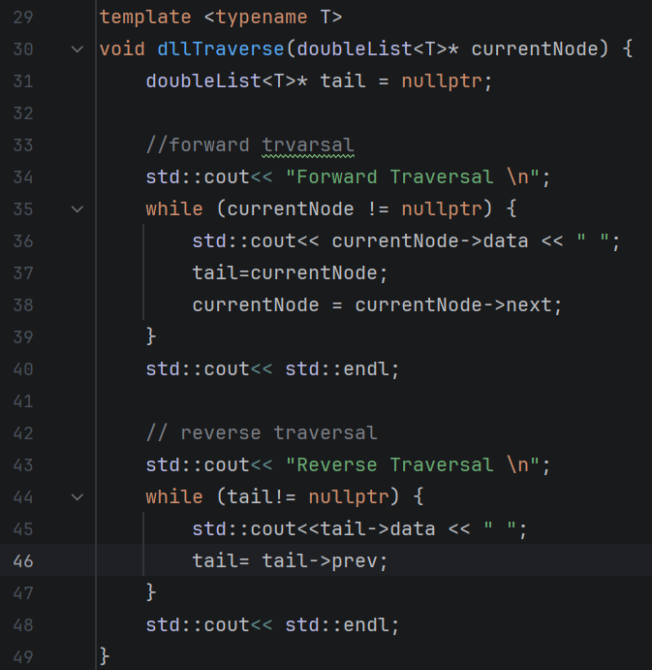
Insertion at head | 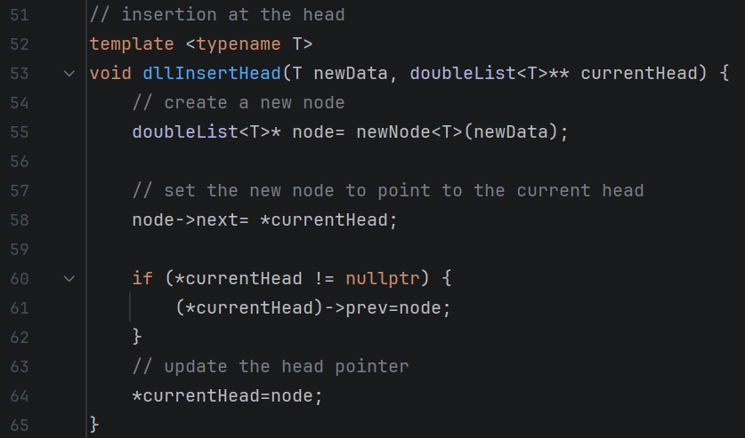
Insertion at any part of the list | 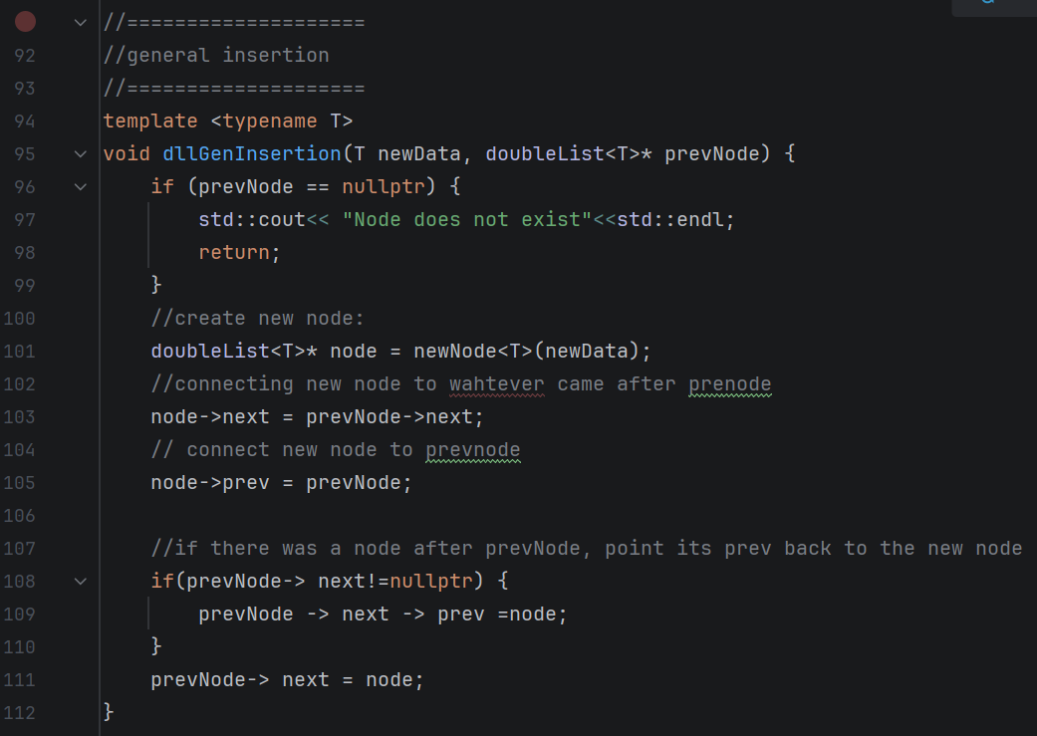
Insertion at the end | 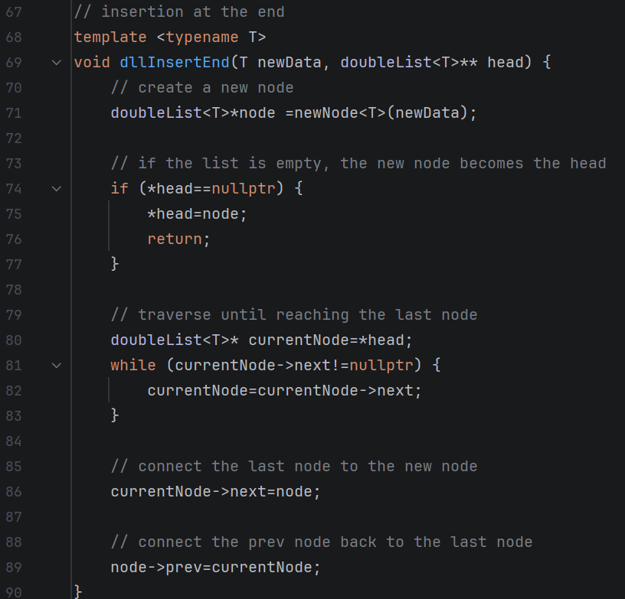
Deletion of a node | 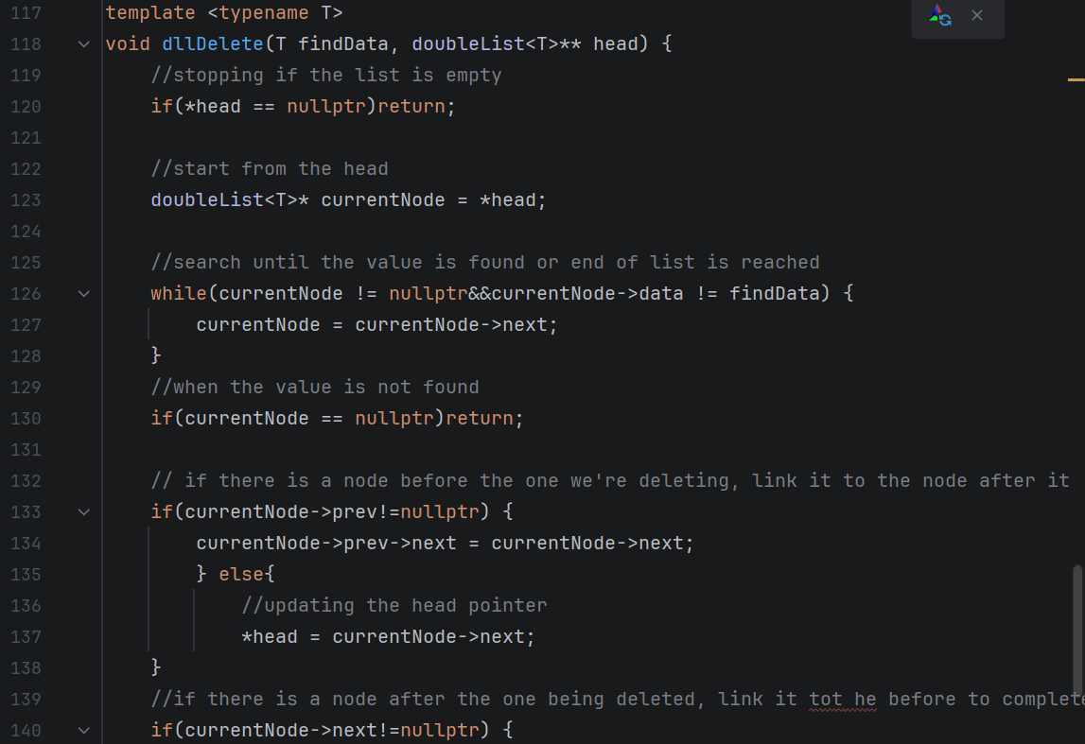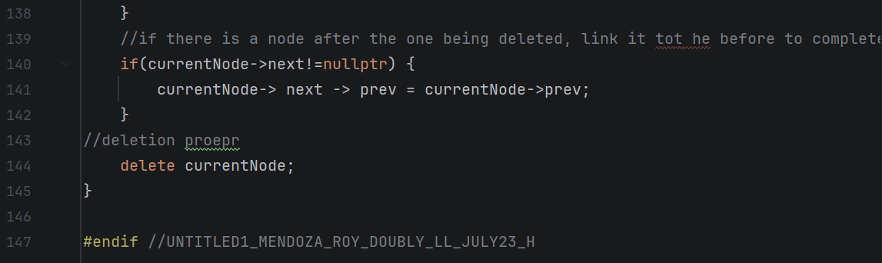

Table 3-3. Code and Analysis for Singly Linked Lists
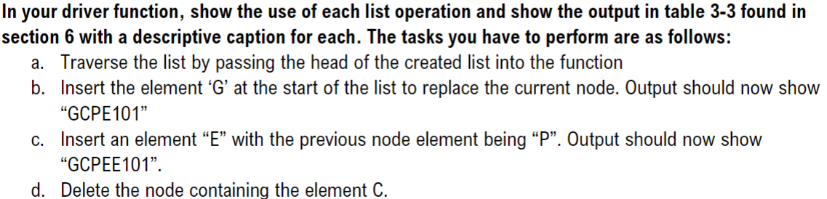
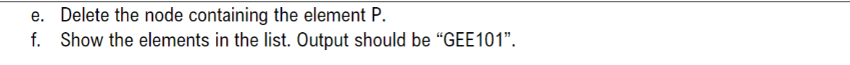
a.
  Source Code
  Console | 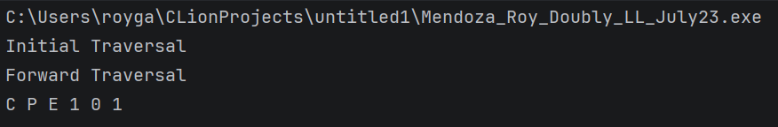
b.
  Source Code | 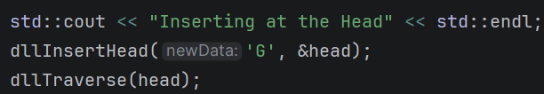
  Console | 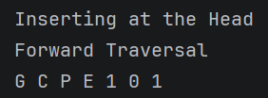
c.
  Source Code
  Console | 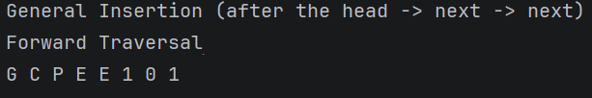
d.
  Source Code | 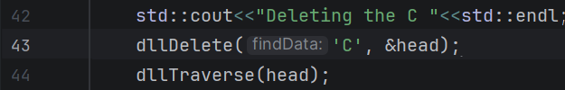
  Console | 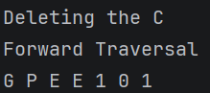
e.
  Source Code | 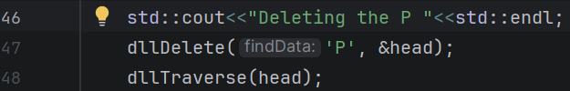
  Console | 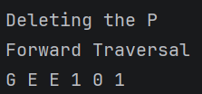
f.
  Source Code | 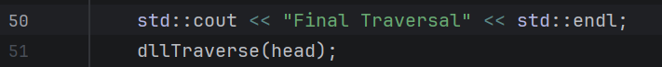
  Console | 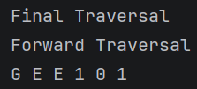

Table 3-4. Modified Operations for Doubly Linked Lists

Screenshots(s) (1st pic would be the singly, 2nd would be the doubly) | Analysis
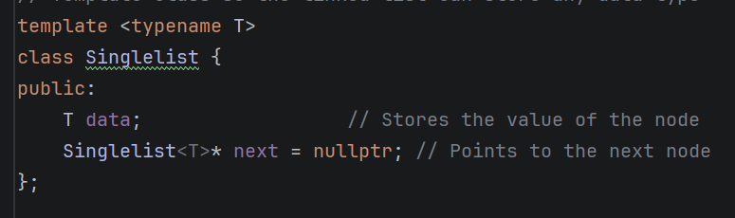  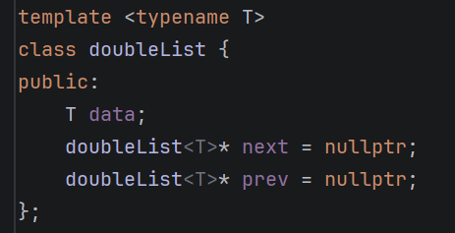 | On this part, the difference or the modification I have done for it to become a doubly was to set not only a next, but also a previous or prev to allow bidirectional traversal.
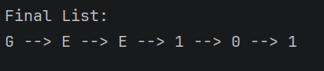  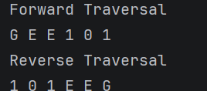 | Added a reverse traversal of the output, final output. Since in singly, the output is just from the Start until the end, In the doubly, there is another output that shows the end upto the start.
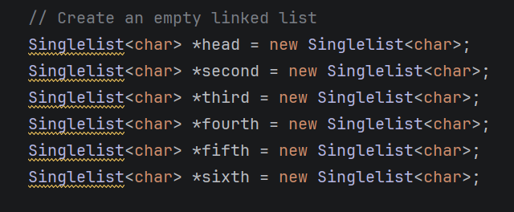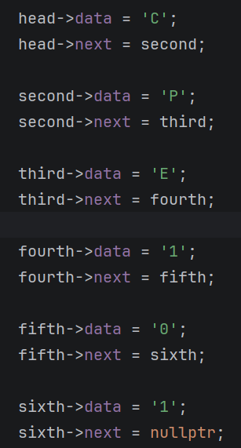  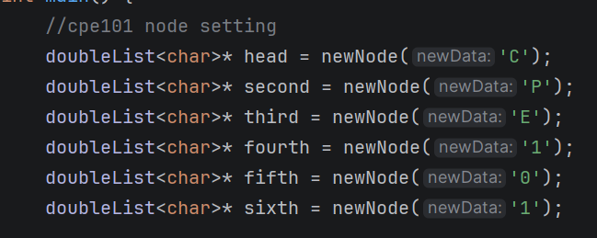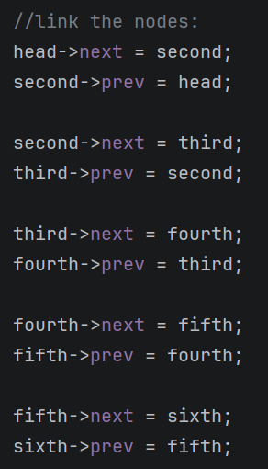 | In the singly linked list, each node was created with the use of the new operator. After the memory allocation, the pointer values had been assigned separately in the main function.  In the doubly linked list, a newNode function was created that allocate memory for a new node and store the data or in this case the char or the letter in each node.
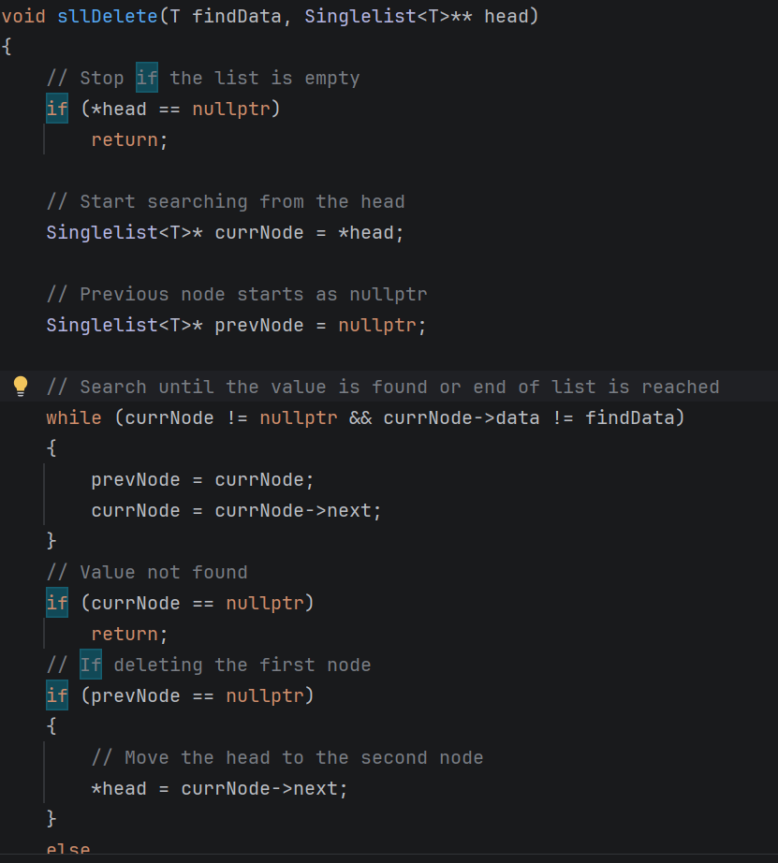  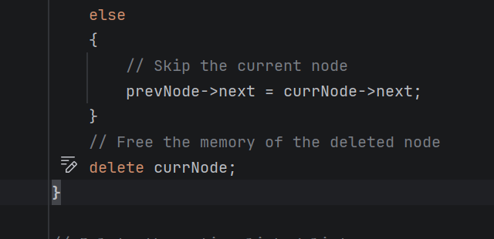  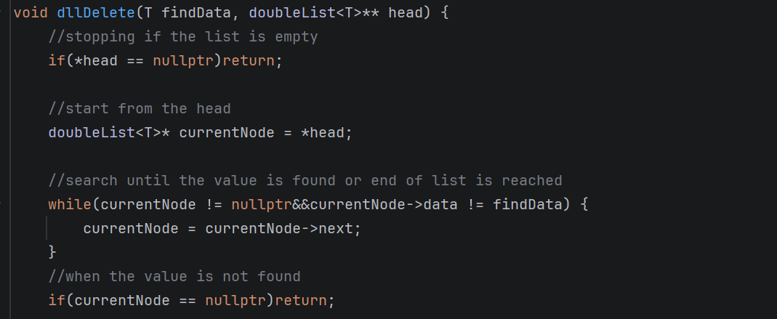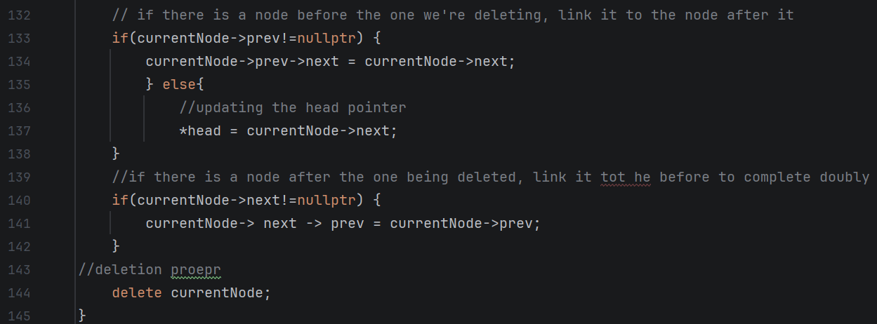 | The difference in the delete function of the singly and the doubly is that, in the singly LL, it only reconnects the next after deleting the node, while the doubly reconnects both the next and the prev to still keep the reverse traversal.

2. ANSWERS TO SUPPLEMENTAL ACTIVITY
Copy and paste the questions from the lab and include your answers after.
TASK:

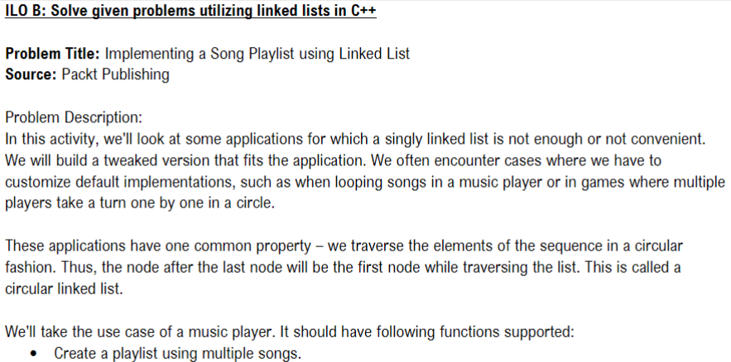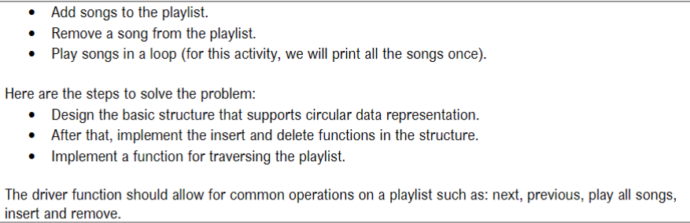
Supplementary CODE:

Header file: | 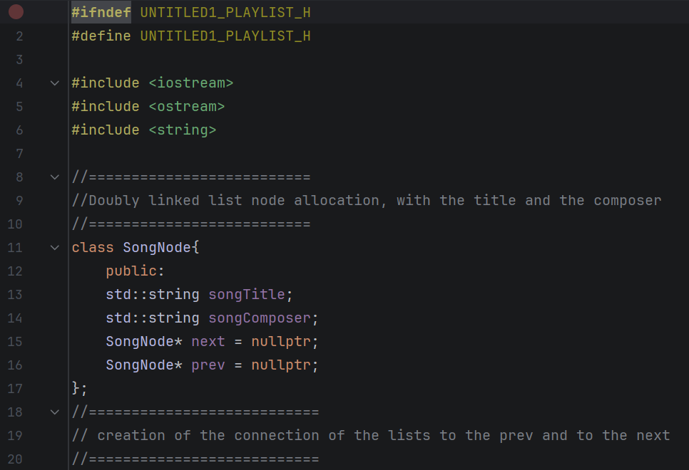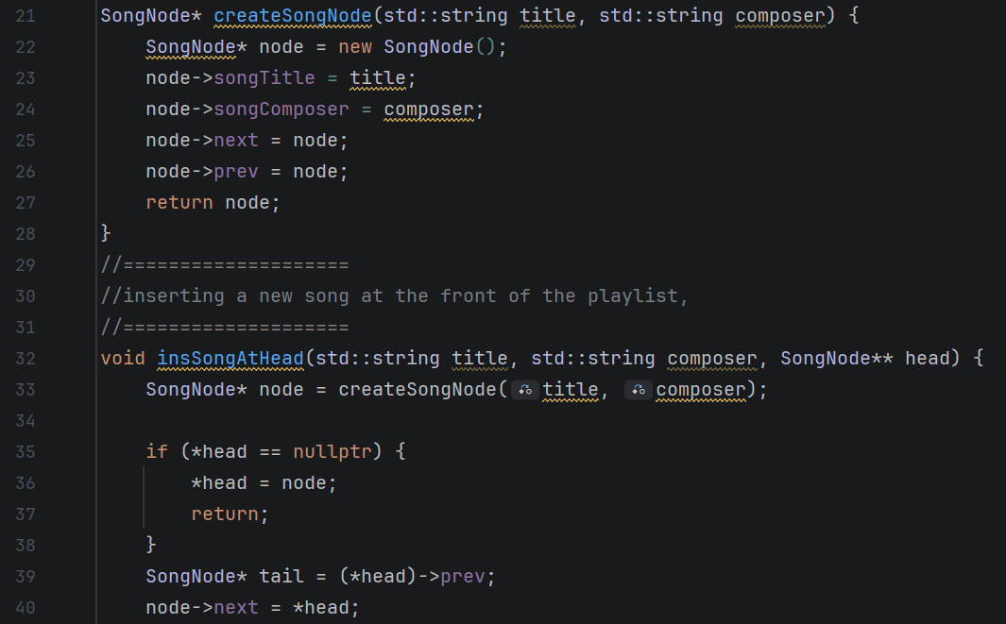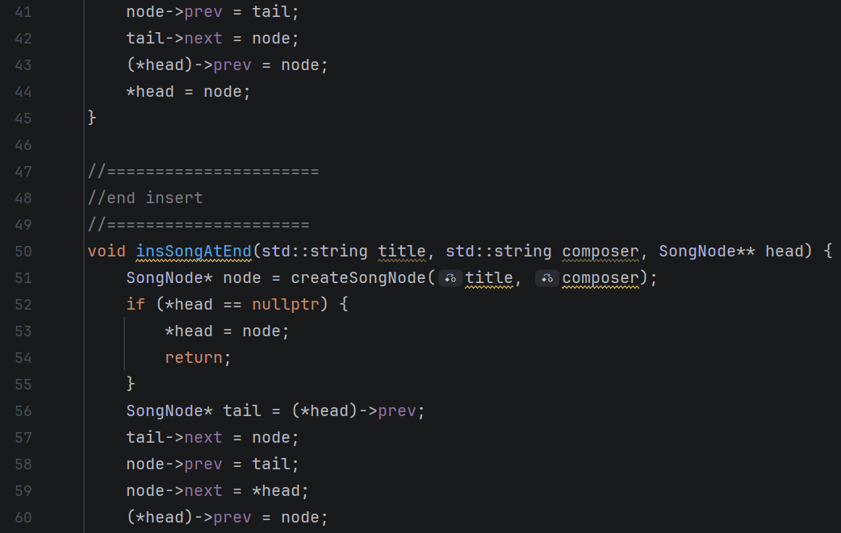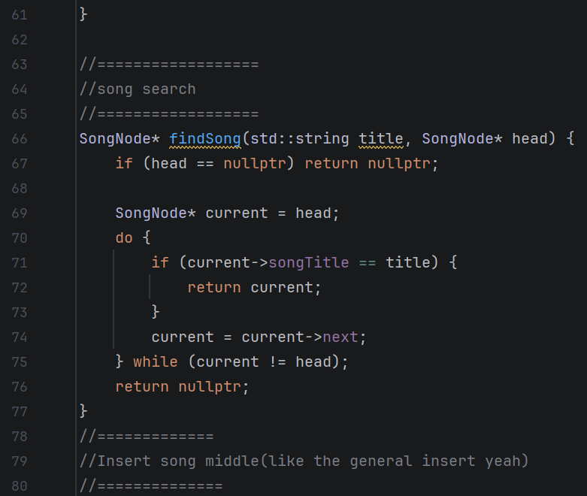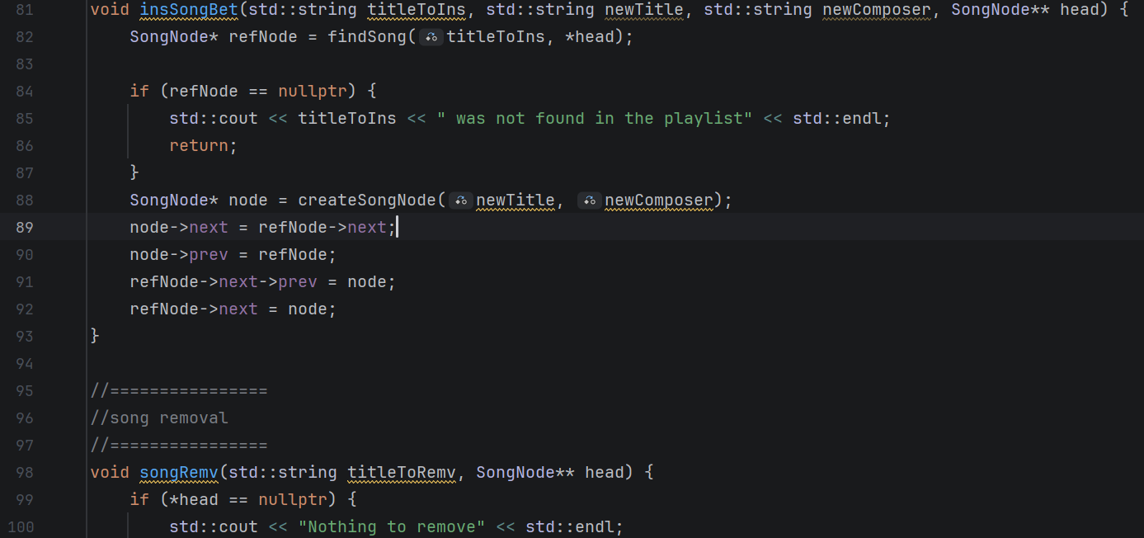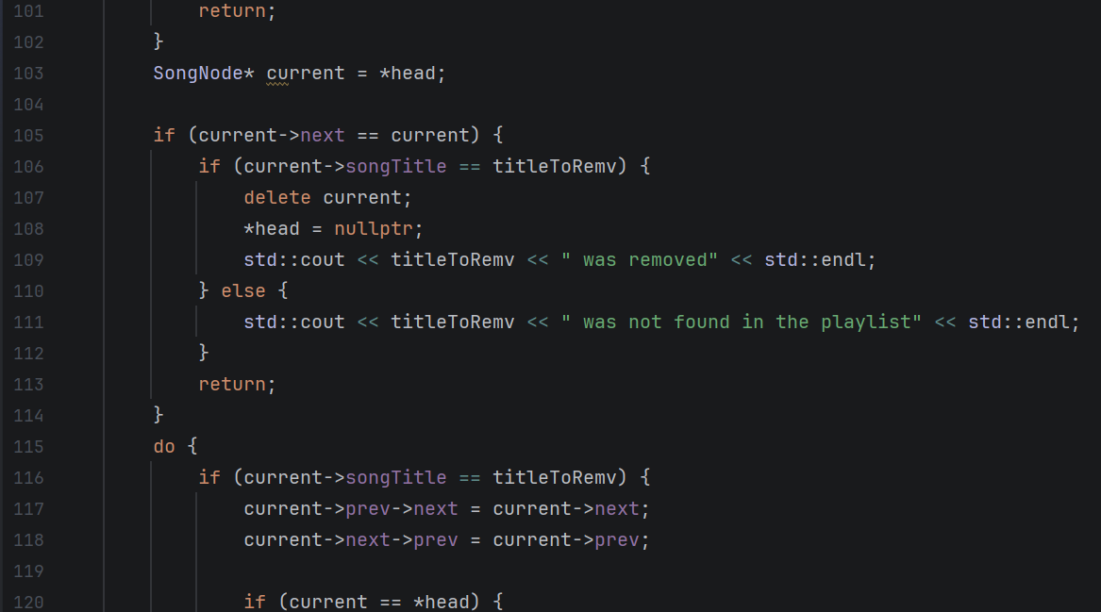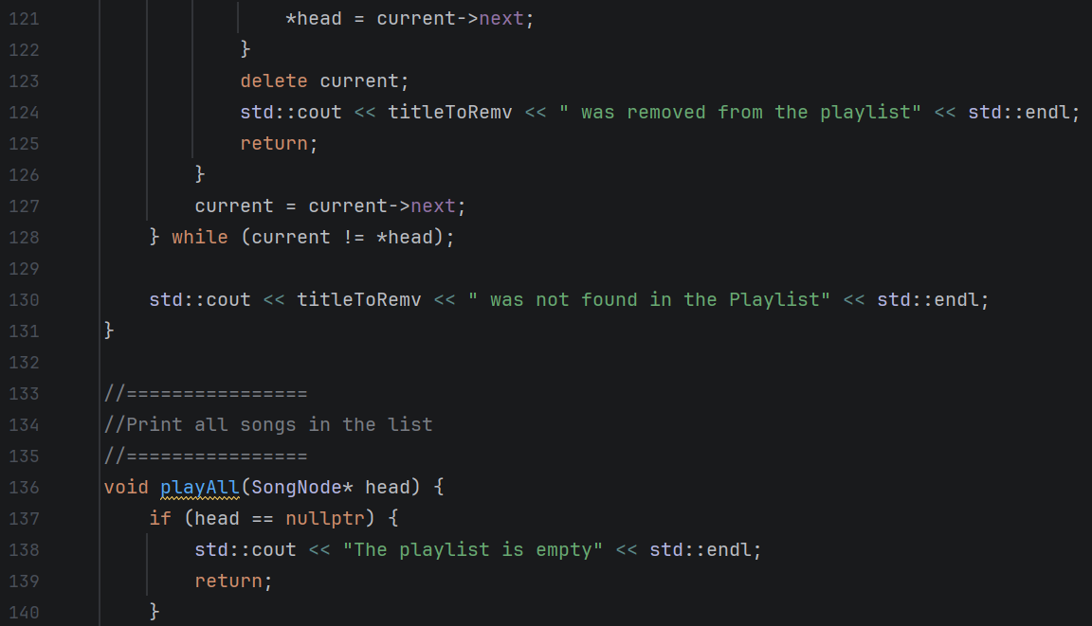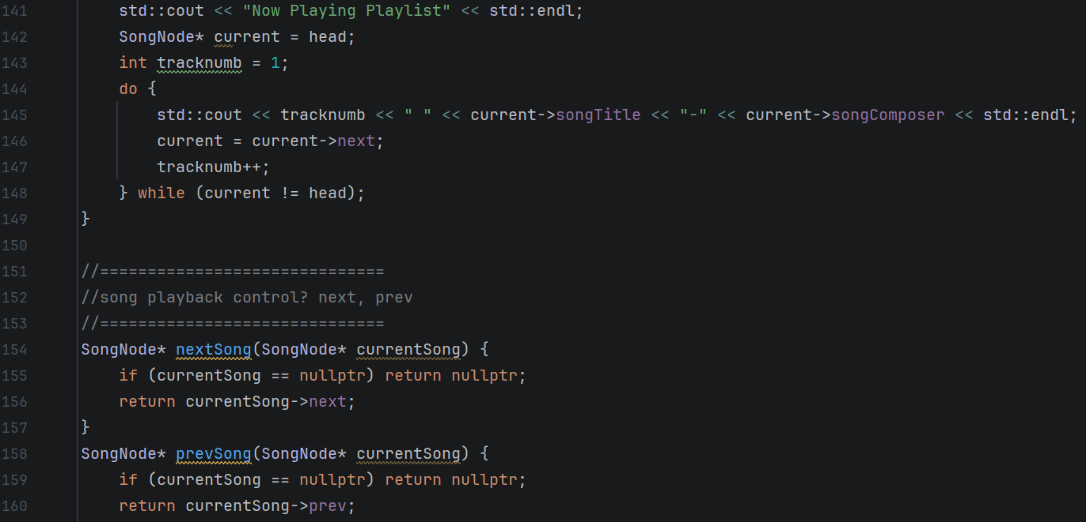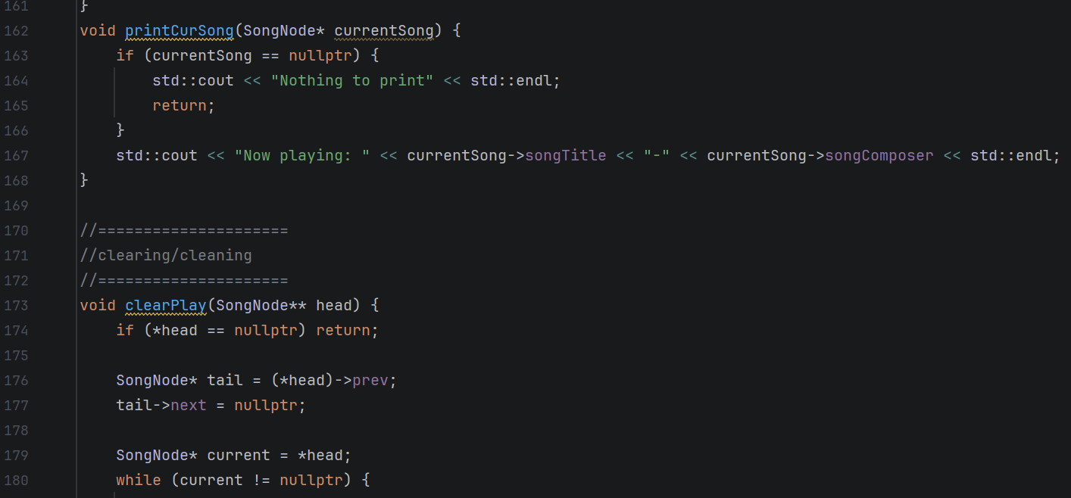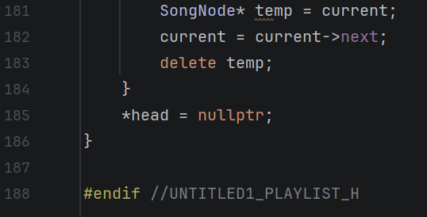
Runner Code: | 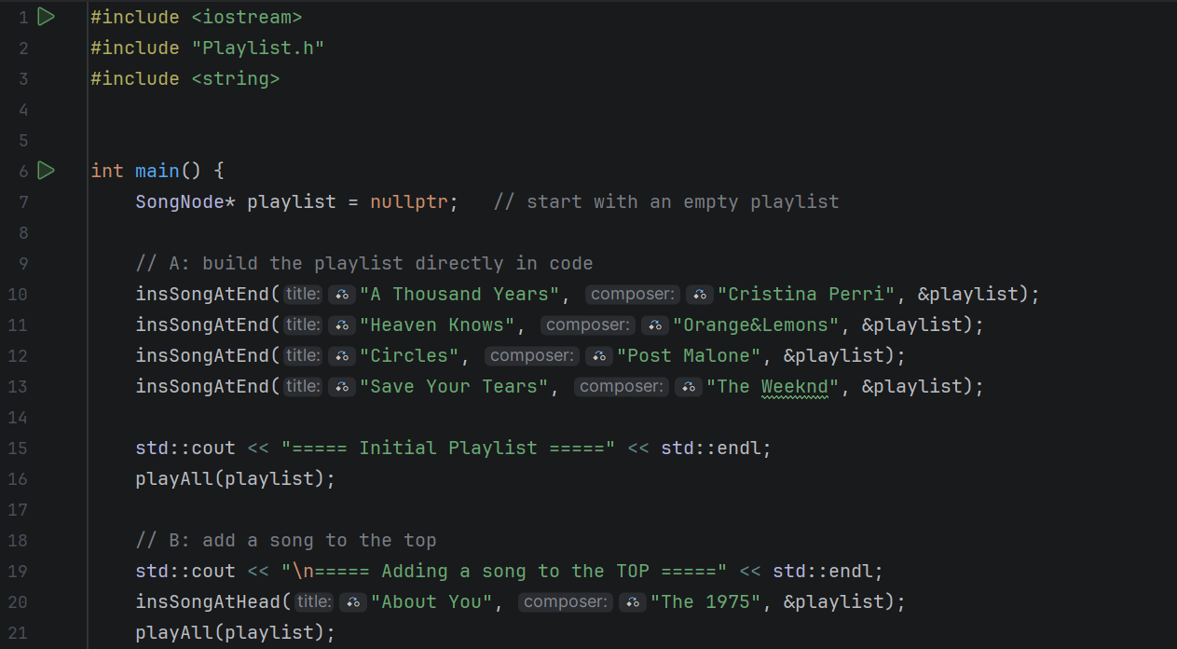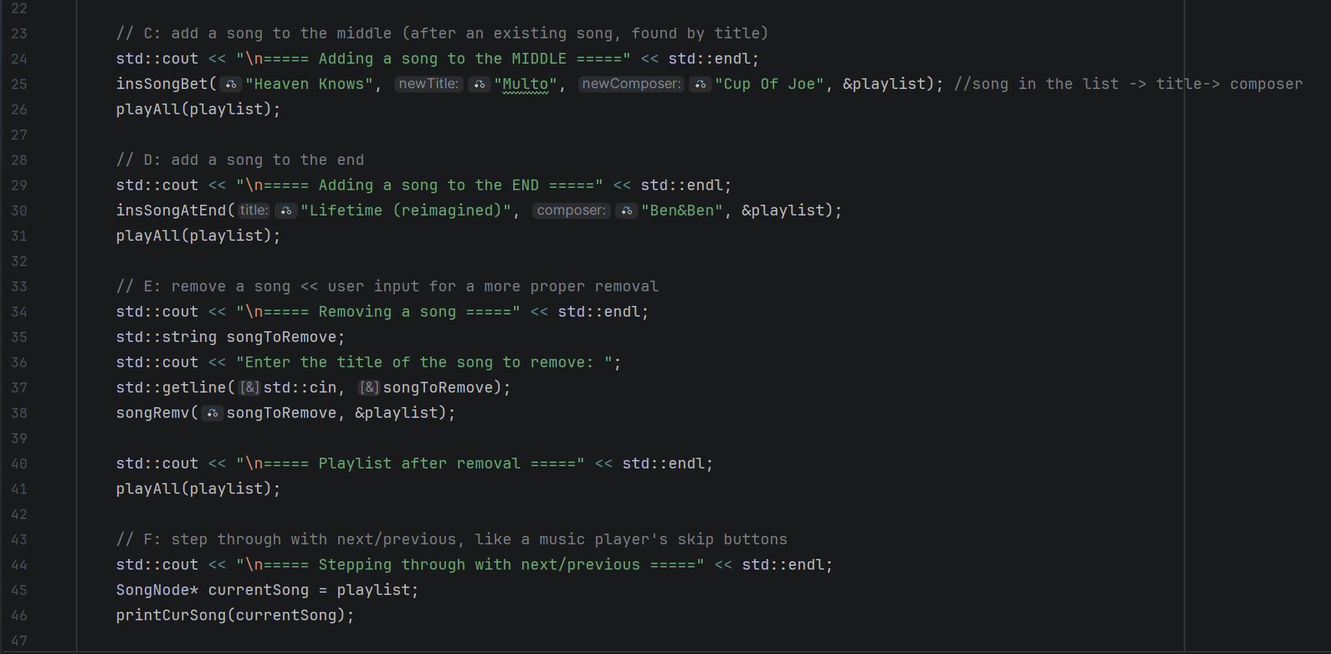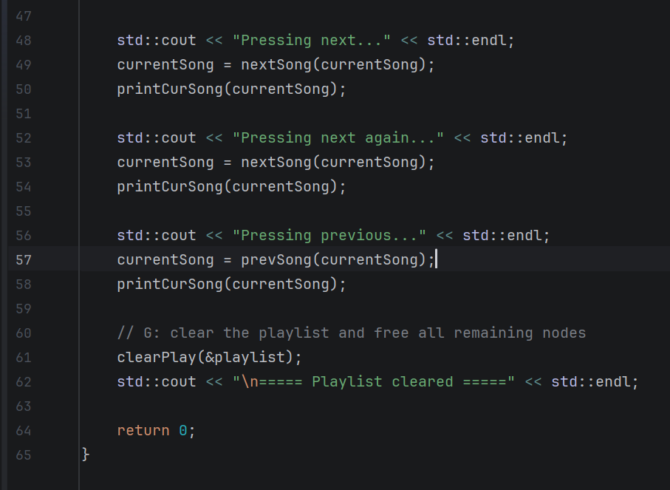

Output:
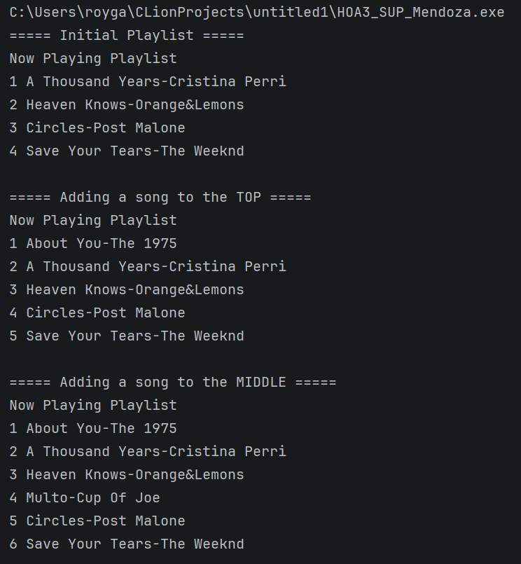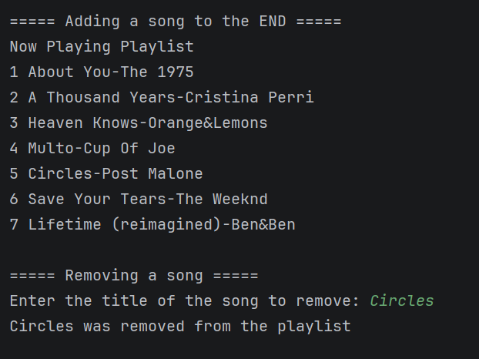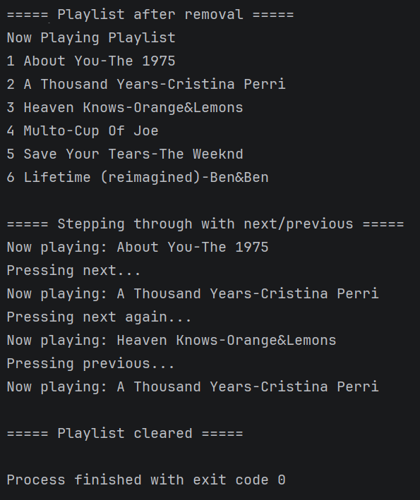

Conclusion:
Provide the following:

- Summary of lessons learned:
> In this lesson, Linked Lists, I was able to understand how to connect things and play and make them run procedurally from node to node. I have learned how to do a singly linked list, a type of linked list that only goes to the next and does not go back. From my observation, I could use this in the creation of a test or online questions, so that the users would not be able to go back to the past, and do something that they would regret. I also was able to understand the function and the creation of a doubly linked list, a type of linked list where the nodes can go back to the previous node, not just the next node. This can be used to create like a library or like the activity in the supplementary, a Playlist of songs.

In essence, this activity could ease and give us an advantage since this is made as our own headers. This lesson, we can apply it to data structures where the data changes very rapidly, since the past sem, we are just doing it basically hard coded, the creation and application of lists and arrays.

- Analysis of the procedure:
>

- Analysis of the supplementary activity:
>

- Concluding statement / Feedback: How well did you think you did in this activity? What are your areas for improvement?:
>

3. ARTIFICIAL INTELLIGENCE (AI) USE DISCLOSURE STATEMENT
I hereby declare that artificial intelligence (AI) tools were used, if applicable, in the preparation of this academic work. The following indicates the nature and extent of AI assistance:

Tools Used:
Examples: ChatGPT, Microsoft Copilot, Grammarly, QuillBot, etc.

Purpose of Use:
Examples: grammar correction, idea generation, formatting, summarization, code assistance, explanation of concepts, etc.

Extent of Use:
Explain how AI was used and confirm that it did not replace original thinking, analysis, authorship, or completion of the required work.

By submitting this activity, I affirm that my use of AI complies with T.I.P.’s AI usage policy and does not exceed the permitted limits for similarity, automated content generation, or academic assistance.

I understand that any false, incomplete, or misleading disclosure may be subject to investigation in accordance with due process and may result in sanctions for violation of existing T.I.P. policies.

Lab activities, templates, and related instructional materials shall not be reuploaded, reproduced, distributed, or shared with external organizations or third parties without the prior express written permission of the Technological Institute of the Philippines.

